**PROJECT PHASE DESIGN – II:**

**CUSTOMER JOURNEY MAPS:**

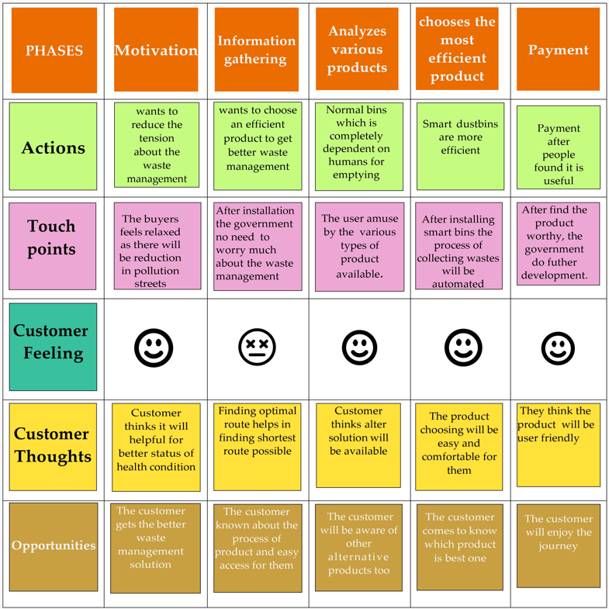

**SOLUTION REQUIREMENTS (FUNCTIONAL & NON-FUNCTIONAL):**

**FUNCTIONAL REQUIREMENTS:**

|  |  |  |
| --- | --- | --- |
| **FR No.** | **Functional Requirement (Epic)** | **Sub Requirement (Story / Sub-Task)** |
| FR-1 | Detailed bin inventory | * We can see bin details in the Dashboard – capacity, waste type, last measurement, GPS location and collection schedule or pi |
| FR-2 | Real time bin monitoring | * Ultrasonic sensor is used to indicate the level of garbage * MQ-136-Hydrogen Sulfide Gas Sensor is used to detect the foul smell of the garbage * With real-time data and predictions, you can eliminate the overflowing bins and stop collecting half-empty ones. * Sensors recognize picks as well; so you can check when the bin was last collected. |
| FR-3 | Expensive bins | * We help you identify bins that drive up your collection costs. The tool calculates a rating for each bin in terms of collection costs |
| FR-4 | Adjustment of bins | * Based on the historical data, you can adjust bin capacity or location where necessary |

**NON-FUNCTIONAL REQUIREMENTS:**

|  |  |  |
| --- | --- | --- |
| **FR No.** | **Non-Functional Requirement** | **Description** |
| NFR-1 | **Usability** | With user experience as the core, the analysis of users’ product usability can indeed help designers better understand users’ potential needs in waste management, behaviour and experience. |
| NFR-2 | **Security** | Use a reusable bottles Use reusable grocery bags Purchase wisely and recycle Avoid single use food and drink containers. |
| NFR-3 | **Reliability** | Smart waste management is also about creating better working conditions for waste collectors and drivers by reducing the collection of empty bins. |
| NFR-4 | **Performance** | Customers are hence provided data-driven decision making, and optimization of waste collection routes, frequencies, and vehicle loads resulting in route reduction by at least 30%. |
| NFR-5 | **Availability** | By developing & deploying resilient hardware and beautiful software we empower cities, businesses, and countries to manage waste smarter. |
| NFR-6 | **Scalability** | In most of the villages , garbages are not cleaned for longer time .so by smart bins will help them to make their places clean and also it is more cost effect and scalability when we moves to smarter |

**DATA FLOW DIAGRAM:**

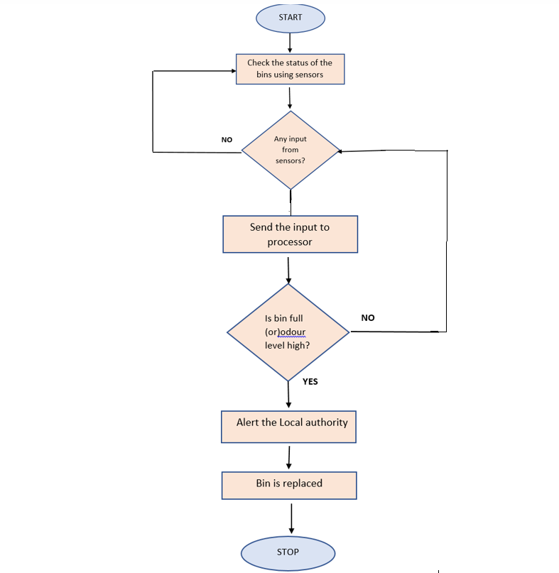



**TECHNOLOGY ARCHITECTURE:**

**ARCHITECTURAL DIAGRAM:**

